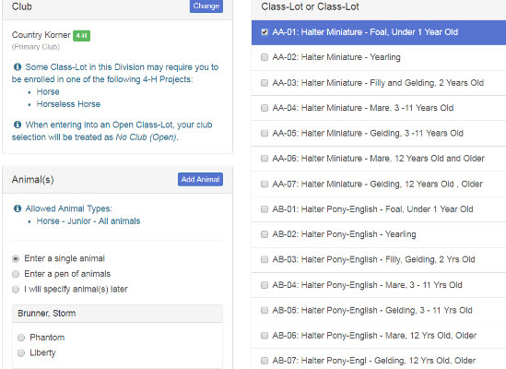
MULTIPLE ENTRIES FOR HORSE AND ALL NON-ANIMAL PROJECTS
DEPT 106, HORSE ENTRIES
You will be able to
- add your animal
- Then select the classes for that animal all on the same screen.
If you have a second animal, you can then add that animal and select their classes.

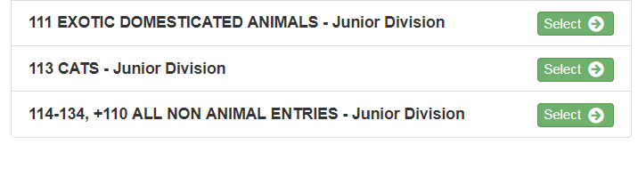
ALL NON-ANIMAL ENTRIES
Dept 110, 114-134
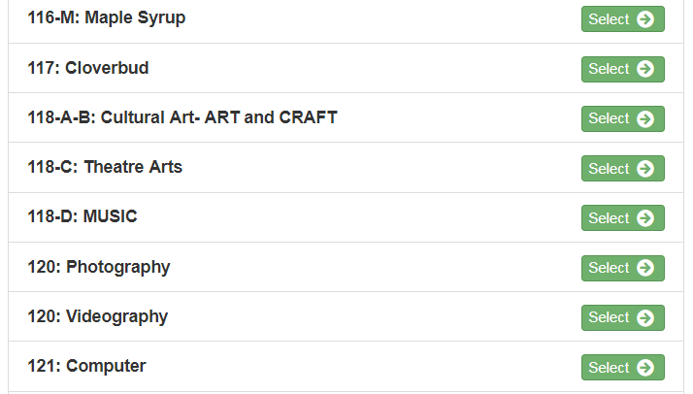
From Foods and Clothing to Vet Science and Crops, you will find all non-animal project entries at the very bottom of the “Choose Department and Division” drop down box. Once you select this,

The next screen displays all non-animal projects in the same numerical order as found in the paper fair book. Select the project of choice.

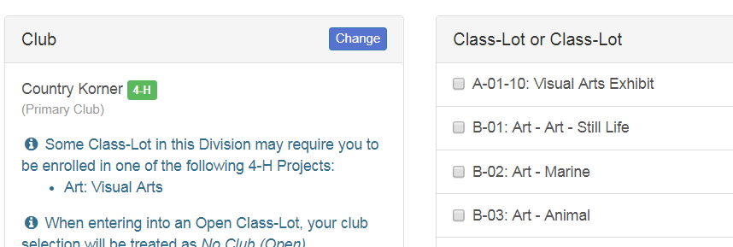
You may now select ALL your entries on the screen. Remember that some projects have limits so you will not be allowed to go over that limit.
(IF you are in 4-H and FFA, be sure to select which club you are entering this project through)

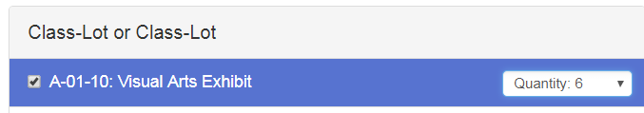
VISUAL ARTS – Exhibit 1-10
Once you check the box, you will see the option for 1-10 entries. Select the appropriate number.

